|  |  |  |  |  |  |
| --- | --- | --- | --- | --- | --- |
| **Module No:** | 1 | **IU No:** | 5 | **Exercise No.** | 5 |

|  |  |
| --- | --- |
| **Lab Assessment Statement** | **Assignment 4 – Implement webhook integration with external App**  **Referring to Assignment-1's Project Scenario,**  The scope of this assignment is to implement webhook Integration for notification using Slack for ‘XYZ Cars Pte Ltd’.  These are the steps provided to build an API.   1. Set up slack for Integration 2. Creating an App for webhook integration 3. Enabling Webhook in App 4. Implement webhook Integration in XYZ portal which is already developed. 5. Testing using Postman 6. Use the API in React Application.   **Provide the source code of developed application.**  **Provide screen capture of final result pages for API testing.** |
| **Technical Environment** | - Spring Boot, Slack for Integration, POSTMAN, React JS |
| **Guidelines** | - |
| **Duration** | 120 mins |

**Solution**

1. Set up slack for Integration

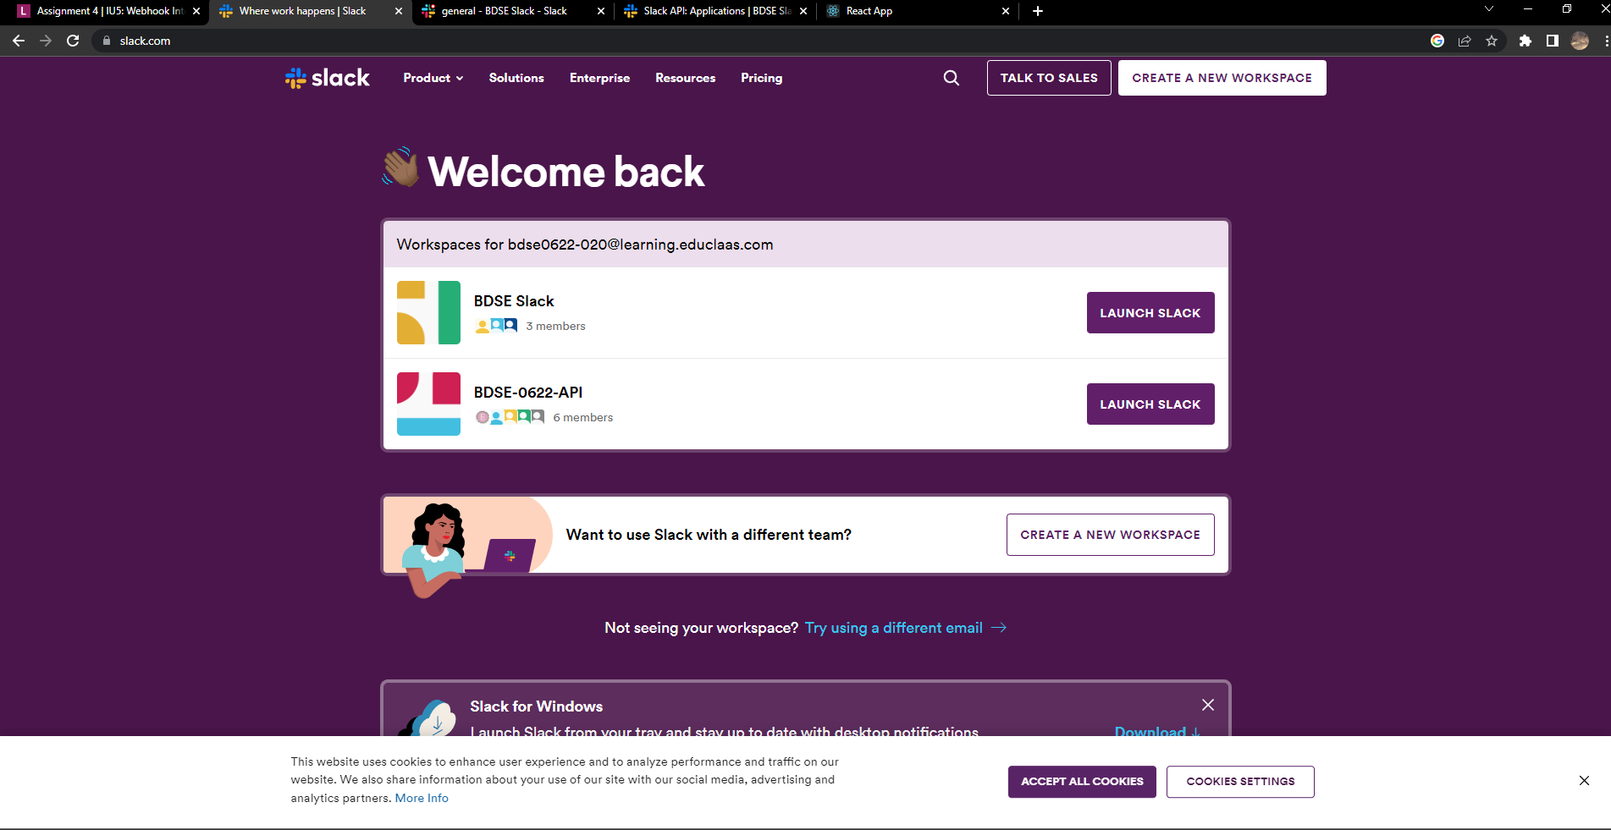

1. Creating an App for webhook integration

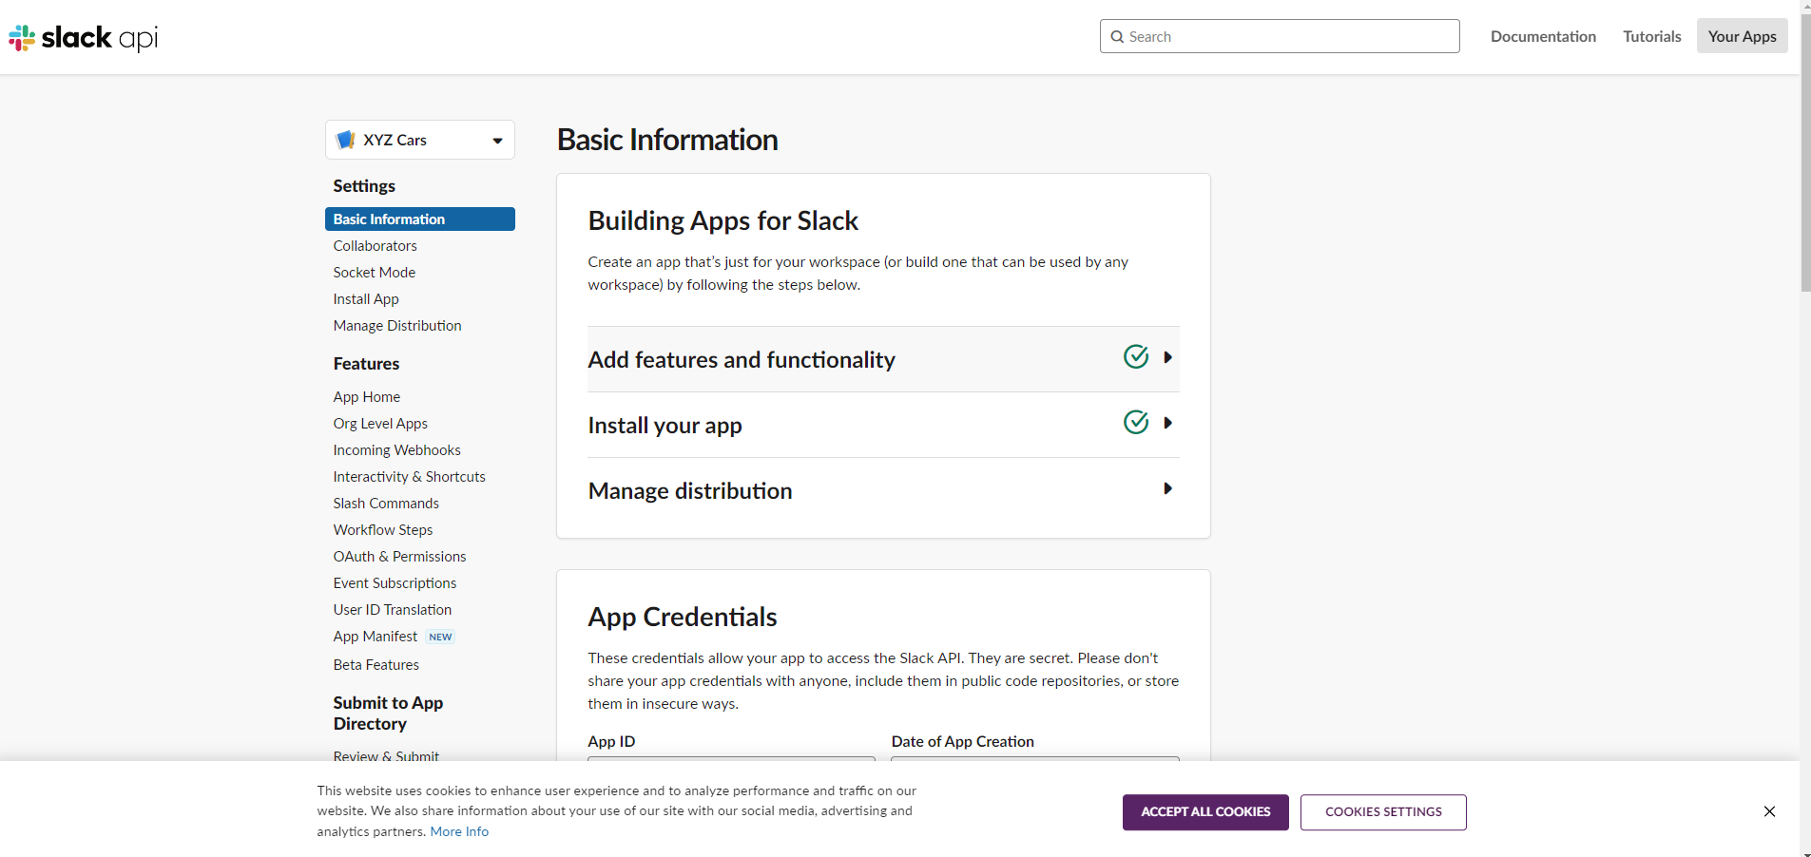

1. Enabling Webhook in App

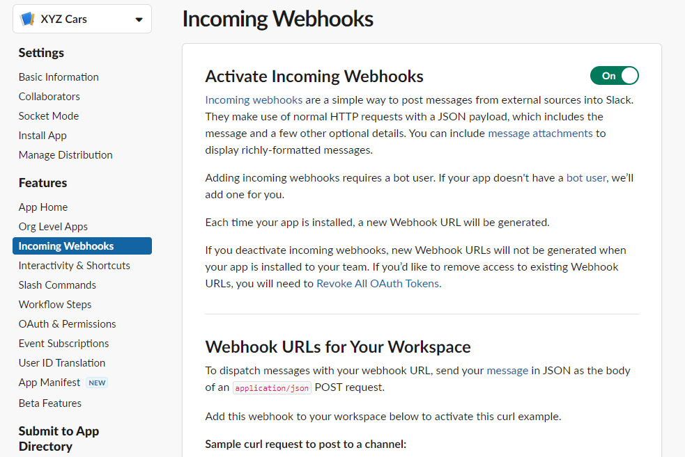

1. Implement webhook Integration in XYZ portal which is already developed.

**Pojo**

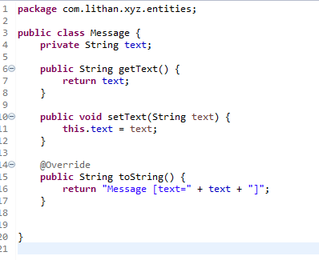

**Service**

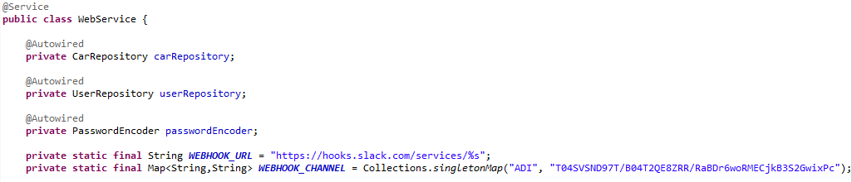

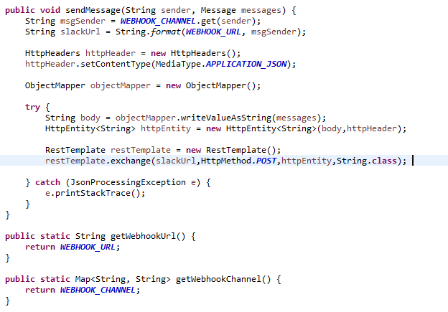

**Controller**

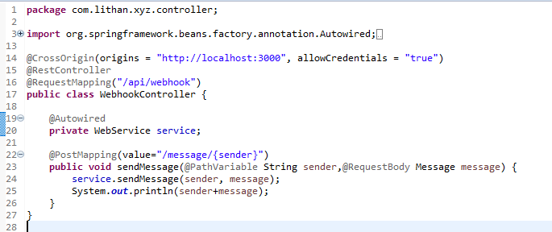

1. Testing using Postman

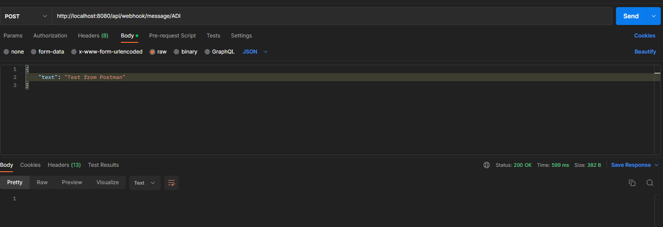

Result

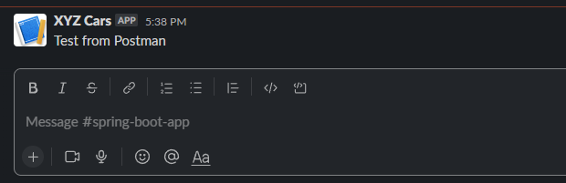

1. Use the API in React Application.

The Page

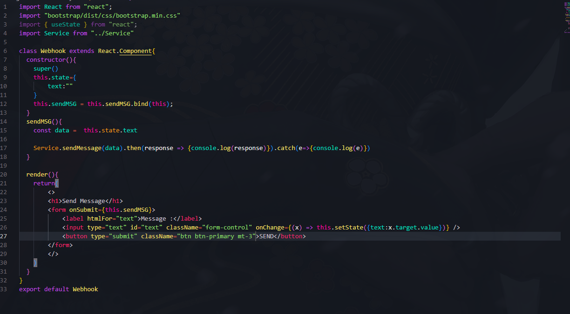

Service

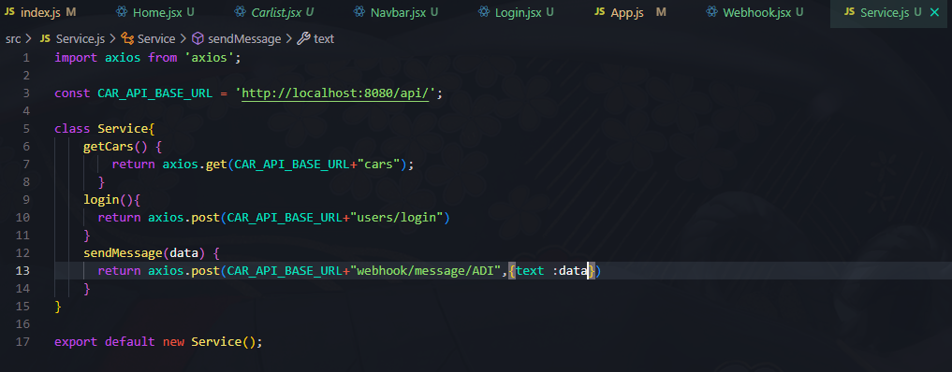

Result:

